**PHASE 3**

**PUBLIC HEALTH AWARENESS CAMPAIGN ANALYSIS**

1. **Dataset Acquisition:**

   Download the dataset from the provided Kaggle link, which contains data related to mental health in the tech industry. Make sure you have it saved locally.

2. **Define Analysis Objectives:**

   Clearly define the objectives of your public health awareness campaign analysis. What specific insights or goals are you trying to achieve with this data?

3. **Data Preprocessing:**

   Begin with data preprocessing to ensure data quality and accuracy. This may involve tasks like handling missing values, removing duplicates, and dealing with outliers.

4. **Data Exploration:**

   Explore the dataset to understand its structure and the variables it contains. You can use tools like Python or IBM Cognos for this step.

5. **Data Visualization:**

   Use IBM Cognos for visualization as you mentioned. Create meaningful and informative visualizations to gain insights from the data.

6. **Analysis and Insights:**

   Perform the analysis based on your defined objectives. This could involve statistical analysis, trend identification, or any other relevant methods.

7. **Campaign Strategy:**

   Based on your analysis, develop a public health awareness campaign strategy. Consider what actions or initiatives can be taken to address the insights gained from the data.

8. **Report and Presentation:**

   Present your findings and campaign strategy using IBM Cognos reports and visualizations. Ensure the information is clear and accessible.

**BAR CHART:**

A bar chart or bar graph is a chart or graph that presents categorical data with rectangular bars with heights or lengths proportional to the values that they represent. The bars can be plotted vertically or horizontally. A vertical bar chart is sometimes called a column chart.

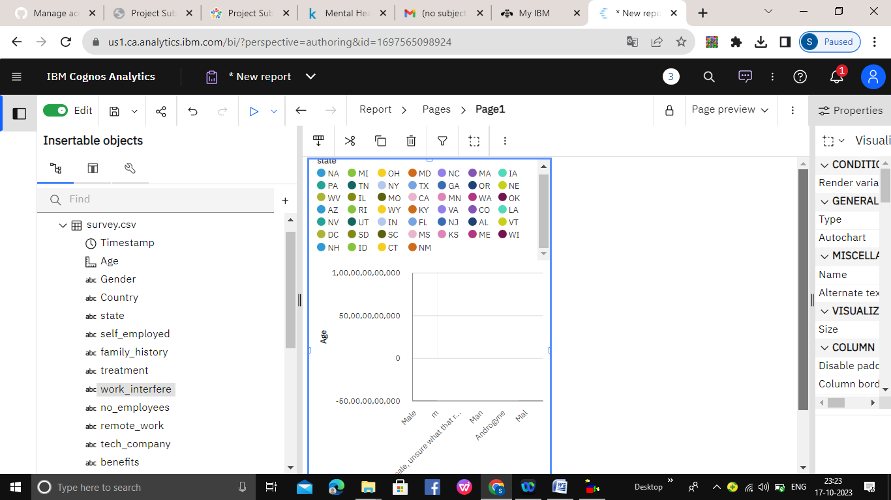

**SCATTER PLATS:**

A scatter plot is a type of plot or mathematical diagram using Cartesian coordinates to display values for typically two variables for a set of data. If the points are coded, one additional variable can be displayed.

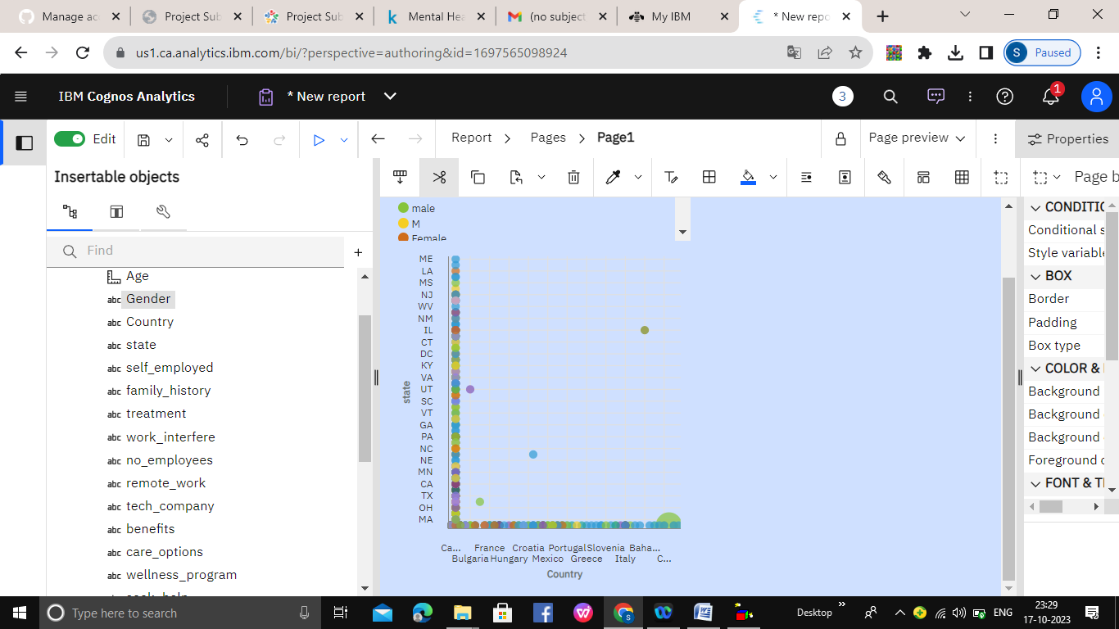

**FLOTING BAR CHART:**

Floating bar charts are charts with a single or multiple bars floating between a minimum and maximum value instead of being connected to the axis. It displays information as a range of data by plotting two Y-values(low and high) per data point.

